Request for Program Modification

Oklahoma State Regents for Higher Education

Institution submitting request: Click here to select your institution.
Contact person: Click here to enter text.
Title: Click here to enter text.
Phone number and email address: Click here to enter text.

Current title of degree program (Level II): Click here to enter text.
Current title of degree program (Level III): Click here to enter text.
State Regent’s three-digit program code: Click here to enter text.
Degree Granting Academic Unit: Click here to enter text.
With approved options in: A. Click here to enter text.
B. Click here to enter text.
C. Click here to enter text.
D. Click here to enter text.
E. Click here to enter text.
TYPE OF REQUEST: Check all appropriate types of changes and complete ONLY the appropriate page(s). Excluding program deletions and suspensions, for modifications to be considered for State Regents’ approval, the program must be current in the 5-year program review cycle. The Degree Program Review schedule can be found at http://www.osrhe.edu/oeis/ProductivityReport/RevParams.aspx

Date next review for the program is due: Click here to enter a date.
Complete and return ONLY this cover sheet AND the appropriate page(s) specifying the requested modification!

NOTE: Information not included in the requested modification may cause a delay in processing.

☐ (1) Program Deletion
☐ (2) Program Suspension
☐ (3) Change of Program Name and/or Degree Designation
☐ (4) Option Addition
☐ (5) Option Deletion
☐ (6) Option Name Change
☐ (7) Program Requirement Change
☐ (8) Other Degree Program Modification (non-substantive)
☐ (9) Program Reinstatement
☐ (10) This modification affects a Cooperative Agreement Program

Signature of President: ______________________________________Date: Click here to enter a date.

Date of Governing Board Approval: Click here to enter a date.

Oklahoma State Regents for Higher Education
(7) Program Requirement Change
REQUEST FOR PROGRAM MODIFICATION
(continued)

Institution submitting request: Click here to select your institution.

Program name and State Regents’ three-digit program code to be modified:
Click here to enter program name and program code.

(7) PROGRAM REQUIREMENT CHANGES

NOTE: Information not included on the requested action may cause a delay in processing.

Select all that apply:

☐ Course requirement change (change in number of core courses, electives, general education, etc. Changes in course prefixes that do not effect content should be reported, but do not require approval.)

☐ Degree program requirement change (i.e. prerequisites, minimum GPA for admission or other admission criteria changes, graduation criteria change, etc.)

☐ Total credit hours for the degree will NOT change.

☐ Total credit hours for the degree WILL change from to
Explain: Click here to enter text.

Summary of changes (attach no more than one page if space provided is inadequate, as well as the form showing the current and proposed curriculum):
Click here to enter text.

Number of new courses being added to course catalog/inventory: Click here to enter text.
List new courses being added to course catalog/inventory: Click here to enter text.
Number of courses being deleted from course catalog/inventory: Click here to enter text.
List courses being deleted from course catalog/inventory: Click here to enter text.

Reason for requested action (attach no more than one page if space provided is inadequate):
Click here to enter text.

Will requested change require additional funds from the State Regents? ☐No ☐Yes
If yes, please specify the number of the additional costs, the source of the funds, and how they will be expended (attach no more than one page if space provided is inadequate).
Click here to enter text.

Will requested change impact an embedded certificate? ☐No ☐Yes
If yes, please specify the certificate name and State Regents’ three-digit program code. A modification to the impacted embedded certificate(s) must accompany the modification request to the main program. Click here to enter text.

Will requested change affect a Cooperative Agreement? ☐No ☐Yes
If yes, a Cooperative Agreement Program Modification Form must be completed and submitted.

For undergraduate degree programs only

As part of the broader work of the Mathematics Success Initiative, the Math Pathways Task Force has identified four gateway mathematics courses that are suitable general education mathematics course options. These courses, College Algebra/Pre-Calculus, Introduction to Statistics, Functions and Modeling, and Quantitative Reasoning, are included on the Course Equivalency Project transfer matrix and provide rigorous mathematical content that is more relevant and appropriate for specific academic majors.

Please respond to the following questions:

- Which mathematics course is required as part of the general education requirements? If the program allows for multiple gateway mathematics course options, provide a rationale for each.
Click here to enter text.
- Describe how the mathematics course was selected and how it best meets the needs of the program’s students.
Click here to enter text.
- How does this mathematics course articulate with your partner institutions?
Click here to enter text.

(For more information regarding the gateway mathematics courses, please contact Dr. Rachel Bates (405) 225-9168)

CURRICULAR REQUIREMENTS

Please either attach current and proposed degree program requirements or use the tables below to list the current requirements in the left column and the proposed requirements in the right column (see appendix A for example).

Indicate the changes clearly. Note any courses deleted from the course catalog/inventory. Asterisk any courses new to the course catalog/inventory.

Current Curriculum
PREFIX AND COURSE # | COURSE TITLE | CR. HRS.
 | Total credit hours
Add additional rows as necessary

Proposed Curriculum
PREFIX AND COURSE # | COURSE TITLE | CR.  HRS.
 | Total credit hours
Add additional rows as necessary

ADMISSION AND/OR GRADUATION REQUIREMENTS

Please either attach current and proposed program admission and/or graduation requirements or use the tables below to list the current requirements in the left column and the proposed requirements in the right column (see appendix B for example).

Indicate the changes clearly. It is only necessary to complete this section if changes to the program’s admission or graduation criteria are being proposed.

Current Program Admission and/or Graduation Requirements  Click here to enter text. | Proposed Program Admission and/or Graduation Requirements  Click here to enter text.

NOTE: This page does not need to be submitted with the completed program requirement change request.

Appendix A

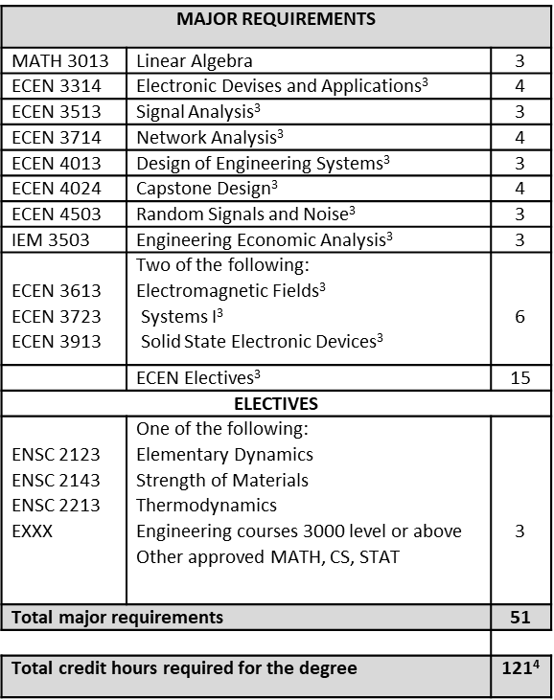

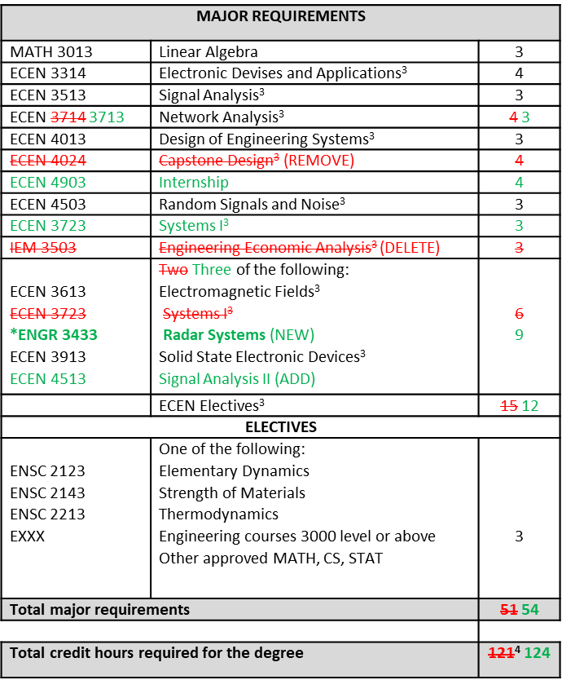

NOTE: This page does not need to be submitted with the completed program requirement change request.

Appendix B

Current Program Admission and/or Graduation Requirements  Admission  - Bachelor of Science in Accounting, with an overall GPA of 3.0 or higher and a GPA of 3.25 in the required prerequisite ACCT courses.  - A GMAT score of 600. GMAT waivers are available for an overall GPA of 3.5 and upper-division accounting coursework GPA of 3.5.  - Completion of the following prerequisite courses: ACCT 2003, ACCT 3003, ACCT 3013, ACCT 3103, ACCT 3113, ACCT 3203, ACCT 3603, ACCT 4033, ACCT 4133, ACCT 4503, ACCT 4553, MSIS 3123, ECON 2103, ECON 2203, LSB 3213, LSB 4323, MKTG 3213, and MGMT 3013  - Admission interview.  - Applicants must submit a completed Graduate College application, resume, one letter of recommendation and a personal statement.  - The application deadline is January 31. | Proposed Program Admission and/or Graduation Requirements  Admission  - An undergraduate degree, with an overall GPA of 3.0 or higher and a GPA of 3.25 in the required prerequisite accounting courses.  - A GMAT score of 550. GMAT waivers are available for an overall GPA of 3.5 and upper-division accounting coursework GPA of 3.5.  - Completion of the following prerequisite courses or course equivalents:  - Foundational Accounting Skills  - Federal Income Taxation  - Intermediate Accounting, I and II  - Cost Accounting  - Accounting Information Systems  - Audit  - Admission interview may be conducted at admission committee’s discretion.  - Applicants must submit a completed Graduate College application, resume, two letters of recommendation and a personal statement.  - The application deadline is March 1.

The University of Oklahoma Health Sciences Center

REQUEST FOR PROGRAM MODIFICATION

___________________________ _________________________________
(Department submitting request) (Program Name & Code being modified)

_________________________________________ _____________
(Reviewed by Academic Program Council) (Date)

Approval Signatures

_________________________________________ _____________
(Department/School Chair/Director) (Date)

_________________________________________ _____________
(College Dean) (Date)

_________________________________________ _____________
(Graduate College) (Date)

_________________________________________ _____________
(Provost) (Date)

Approved by The University of Oklahoma Regents _____________
(Date)

Approved by Oklahoma State Regents for Higher Education _____________
(Date)

